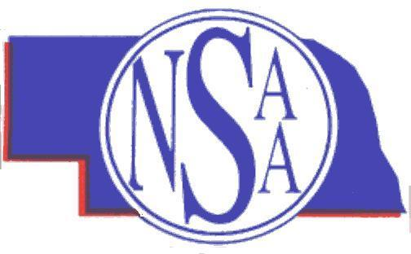
NEBRASKA SCHOOL ACTIVITIES ASSOCIATION

Hurricane Relief Fund Basketball Game

The NSAA shares the nation’s concern regarding the devastation and loss of life in the Gulf Coast states caused by Hurricane Katrina. The NSAA is in support of efforts to assist those states to rebuild and overcome the terrible devastation that occurred. The NSAA Board of Control has approved the scheduling of an exhibition basketball game to support relief efforts.

Benefit Basketball Games. On a one-year-only basis, member schools shall be permitted to schedule one boys and/or one girls basketball game with the proceeds earmarked for a Hurricane Katrina Relief Fund. This exhibition game would be in addition to the seventeen dates that are presently permitted for schools to schedule. The additional game would be optional; schools not wishing to participate in an additional game would not be required to schedule such a game. Schools not wishing to schedule a Hurricane Katrina Relief Fund game may elect to designate some other fundraiser to contribute to the cause.

Parameters for Hurricane Katrina Relief Fund Games.
- Schools may schedule a single varsity game for boys and a single game for girls. Tournaments or other multiple contest arrangements will not be permitted for this specially arranged fundraiser game(s).
- The contest dates for Hurricane Katrina Relief Fund games must be on or after November 28, 2005, and before the start of Subdistrict or District Basketball Tournaments.
- The actual scheduling of such Hurricane Katrina Relief Fund games must be completed before the basketball season begins, and the NSAA shall be apprised of such games at the time the school’s regular season schedule is submitted to the NSAA.
- Hurricane Katrina Relief Fund games will be considered exhibition games and will not count toward the wild card point averages, nor will the outcome be listed in the school’s win-loss record. By eliminating consideration of such contests from the wild card point averages and win-loss records, it may encourage schools to schedule someone in a different class or some geographically proximate opponent.
- If a Hurricane Katrina Relief Fund game is scheduled, only the cost of the game officials may be deducted from the gross receipts. The remaining proceeds will be earmarked for the Hurricane Katrina Relief Fund. It is understood and expected that there will be expenses (travel, utilities, scorekeepers, supervisors, etc.) that must be borne by the competing schools. Schools will not be required to schedule a Hurricane Katrina Relief Fund game.
- In some situations, game officials may choose to donate their services for the Hurricane Katrina Relief Fund games as their contribution to the fundraising project.
- Schools participating in a Hurricane Katrina Relief Fund game will be asked to complete a financial report that will be sent to the NSAA.
- NSAA Premier Corporate Sponsor U.S. Bank has graciously agreed to be the depository for Hurricane Katrina Relief Fund proceeds. Schools will send the check and a copy of the NSAA financial report to the designated U.S. Bank address.
- It is anticipated that when the final Hurricane Katrina Relief Fund payments have been deposited with U.S. Bank, the entire proceeds will be forwarded to the American Red Cross for approved uses in the Gulf Coast states.

